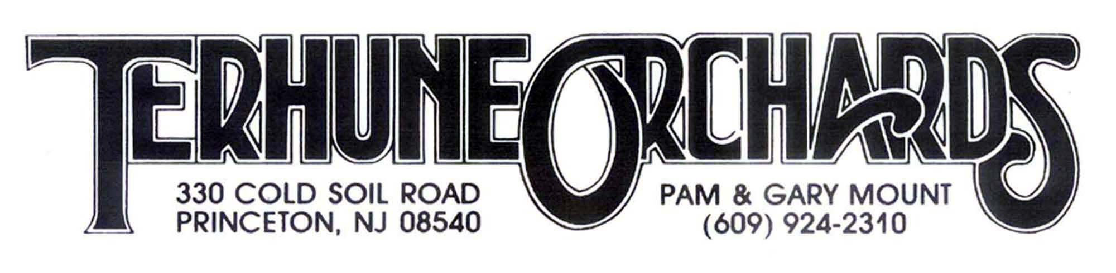

Blueberry Bash Contest

Recipe Submission Form 2018
Must be submitted with sample of actual baked product!

Name: __________________________________________________________

Address: ________________________________________________________

Phone #: ____________________________________

Email: _______________________________________

Recipe Title: __________________________________

Recipe: _________________________________________________________

------------------------------------------------------------------------------------------------------------
Contest rules: Recipe and actual baked product for tasting should be brought to the Farm Store at 330 Cold Soil Road no later than 12 noon on Sunday, July 8th. Judged by Joanne Canady-Brown, owner of Gingered Peach Bakery in Lawrenceville.

By submitting a recipe you are allowing Terhune Orchards to publish it in our newsletter, website and share with our customers.

Prizes: $100 Terhune Orchards Gift Certificate for winner
$50 Terhune Orchards Gift Certificate for honorable mention

